Gurjeet Longia

Theoretical and Computational Methods

April 19, 2019

Mie Theory

**Question 1: How does the spectrum change as you increase the dielectric constant of the surrounding materials? Try n = 1.45 for glass and n = 1.76 for alumina.**

The dielectric function of 1.33 for water.

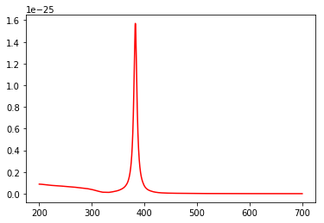

The dielectric function for glass is 1.45.

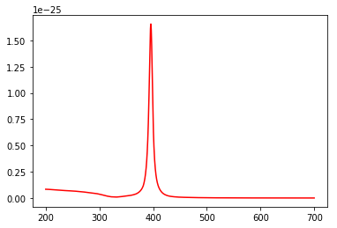

The dielectric function for alumina Is 1.76.

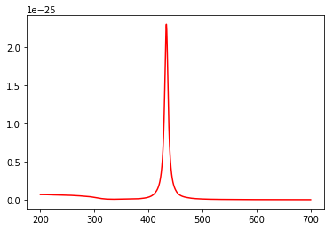

The peaks shift towards the right when you increase the dielectric function of the surrounding materials. The absorbance also increases.

**Question 2: How does the spectrum change as you decrease the dielectric constant of the surrounding materials? Try n = 1.0 for air.**

The dielectric function for air is 1.0.

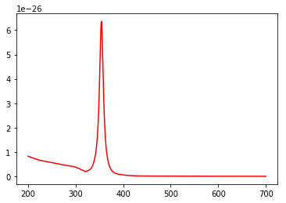

As compared to water, the dielectric function is 1.33.



As you decrease the dielectric constant of the surrounding materials, the spectrum moves towards the left.

**Question 3: How does the spectrum change if you use Au instead of Ag?**

This graph shows the spectrum for gold.

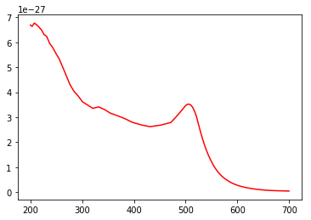

This graph shows the spectrum for silver.



The surrounding material in both of these spectra is air. The spectrum for gold shows a peak around 500 nm and the spectrum for silver around 350 nm. The absorbance for silver is higher than that for gold.

**Question 4: Plot the real and imaginary parts of the dielectric function of Au and Ag as a function of wavelength; what do you notice about the values in the vicinity of the plasmon resonance (i.e. at wavelengths where the strong absorption peak is observed)?**

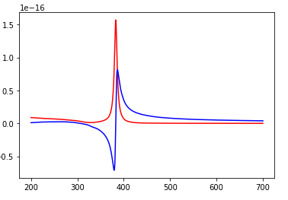

These are the spectra for silver, and the surrounding material is water. The red spectra is the imaginary part and the blue spectra is the real part. The real part has a peak around 380 nm which is a negative absorbance and another peak at around 400 nm. The imaginary part has one peak around 380 nm. The two peaks are both around 380 nm.

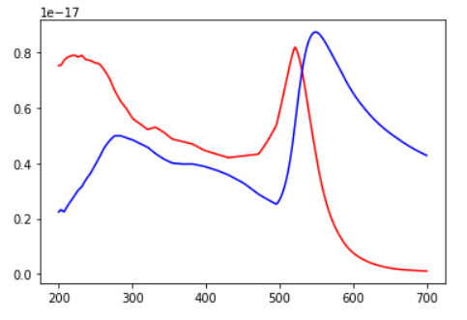

These are the spectra for gold, and the surrounding material is water. The red is the imaginary part and the blue is the real part. The real part also has two peaks, around 300 nm and 550 nm. The imaginary part also has two peaks, around 200 nm and 500 nm. The imaginary part is shifted towards the left.